

**WYNNUM RUGBY CLUB SCOREBOARD**

Contents

1. INTRODUCTION 3

2. POWER AND SAFETY 4

2.1. WARNINGS 4

2.2. CIRCUIT BREAKERS 4

2.3. LED POWER SUPPLIES 4

2.4. POWERING UP 4

2.5. CONTROLLER BATTERIES 4

3. SCORE DISPLAY OPERATION 5

3.1. TOUCHSCREEN CONTROLLER 5

3.2. HOTSPOT CONTROLLER 7

4. SPONSORS DISPLAY OPERATION 9

4.1. CONTROLLER 9

4.2. SOFTWARE 9

4.3. USER MANUAL 9

4.4. SCREEN CONFIGURATION 10

4.5. ADVANCED SETUP 10

4.6. IMPORT PROJECT FILE 12

4.7. UPLOADING 12

4.8. SPONSORS GRAPHICS 13

5. BLOCK DIAGRAMS 14

5.1. SCORE DISPLAY LOGICAL LAYOUT 14

5.2. SCORE DISPLAY POWER LAYOUT 15

5.3. SPONSORS DISPLAY LOGICAL AND POWER LAYOUT 16

6. HARDWARE AND PARTS 17

6.1. SCORE DISPLAY 17

6.2. SPONSORS DISPLAY 18

6.3. TOUCHSCREEN CONTROLLER 19

7. DESIGN FILES 20

8. PROGRAMMING GUIDE 20

8.1. SOFTWARE DEVELOPMENT ENVIRONMENT 20

8.2. SOFTWARE LIBRARIES 21

8.3. RESOURCE FILES 21

8.4. SOURCE CODE 21

8.5. COMPILING 21

8.6. UPLOADING 21

# INTRODUCTION

The scoreboard has two displays:

* **Score Display** – two numerical displays at the top left and right of the scoreboard
* **Sponsors Display** – a long area at the bottom of the scoreboard to display scrolling text or graphics (e.g sponsors names)

The score display and the sponsors display are physically separate and use different controllers (i.e. they are not interlinked).

|  |
| --- |
| C:\Users\Dave\Dropbox\Camera Uploads\2016-07-16 13.58.36.jpg |

# POWER AND SAFETY

## WARNINGS

**The scoreboard is powered by 240VAC and has lethal current inside. The back access panels must be secured and locked shut at all times.**

**If the scoreboard is powered from a generator, you must connect an earthing stake to ensure that the safety switch will function correctly.**

**The scoreboard is resistant to some moisture, but is suitable to be operated in wet weather.**

**In high wind, position the board facing 90 degrees (narrow side on) to the direction of the wind.**

## CIRCUIT BREAKERS

There is a circuit breaker and safety switch box inside the back left access panel that allows the displays to be powered individually. If the safety switch has tripped for any reason you must consult a qualified electrician.

The key to the scoreboard rear panel doors is attached to the hand-held controller.

## LED POWER SUPPLIES

The LED panels are powered by five 5V 40A power supplies inside the display. If a group of LED panels is not lit up, refer to the Support section below.

## POWERING UP

To power up the scoreboard connect a 240VAC lead to the power inlet on the right hand side of the scoreboard.

After power on:

* the Score Display will show a short test pattern. If any individual LED’s do not light up, refer to the Support section below.
* the Sponsor Display shows a splash screen (“Wynnum Rugby” or similar) that may be configured as described in Section 4 below.

The unit must be grounded - either using a normal 3 pin electrical lead or a ground

**If the scoreboard is powered from a generator, you must connect an earthing stake to ensure the safety switch will function correctly.**

## CONTROLLER BATTERIES

The hand held controllers are battery powered – see instructions below for changing the batteries.

# SCORE DISPLAY OPERATION

## TOUCHSCREEN CONTROLLER (DEPRECATED)

### Overview

The touchscreen controller allows control of the scoreboard via a dedicated 2.4GHz radio link.

This design has been deprecated as it did not provide sufficient duration running from AA batteries, and the touchscreen is harder to see in direct sunlight.

Refer to 3.2 for the newer WiFi Hotspot controller.

### Power

The touchscreen controller is powered by 3 x AA batteries that should provide a few hours of continuous use. An indicator on the main screen will show if the batteries are low. To access and replace the batteries, use an Allen-key to undo the large hex screw on the front panel of the controller.

### Splash Screen

The touchscreen controller is fairly intuitive – after switching on it takes about 10 seconds to boot and connect to the scoreboard, then shows a splash screen with the Bugs logo that will disappear after a few seconds (or press ‘skip’ to clear it)

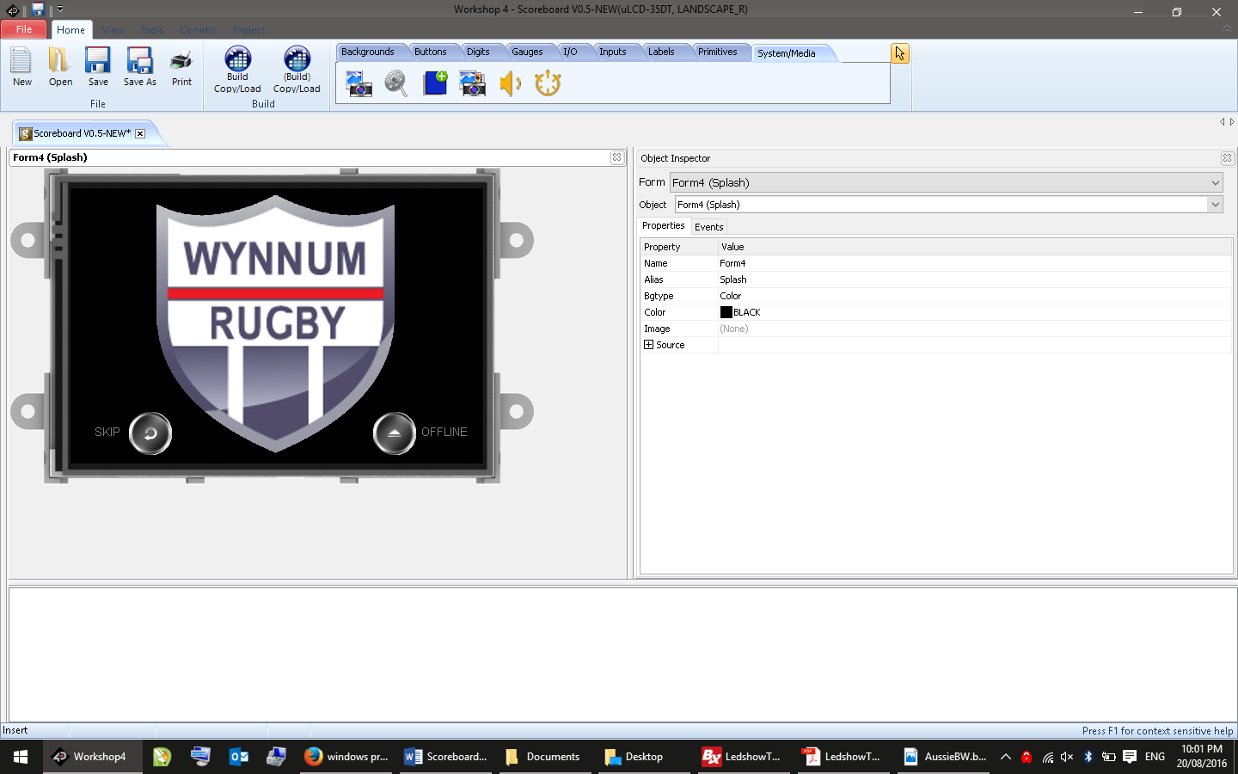

### Main Screen

The main screen has options to select Field 1, Field 2, or Settings.

At this stage Field 2 is only supported in ‘dual screen’ mode.

The controller software has been designed to control two fields (just in case sometime in the future if/when we get another scoreboard).

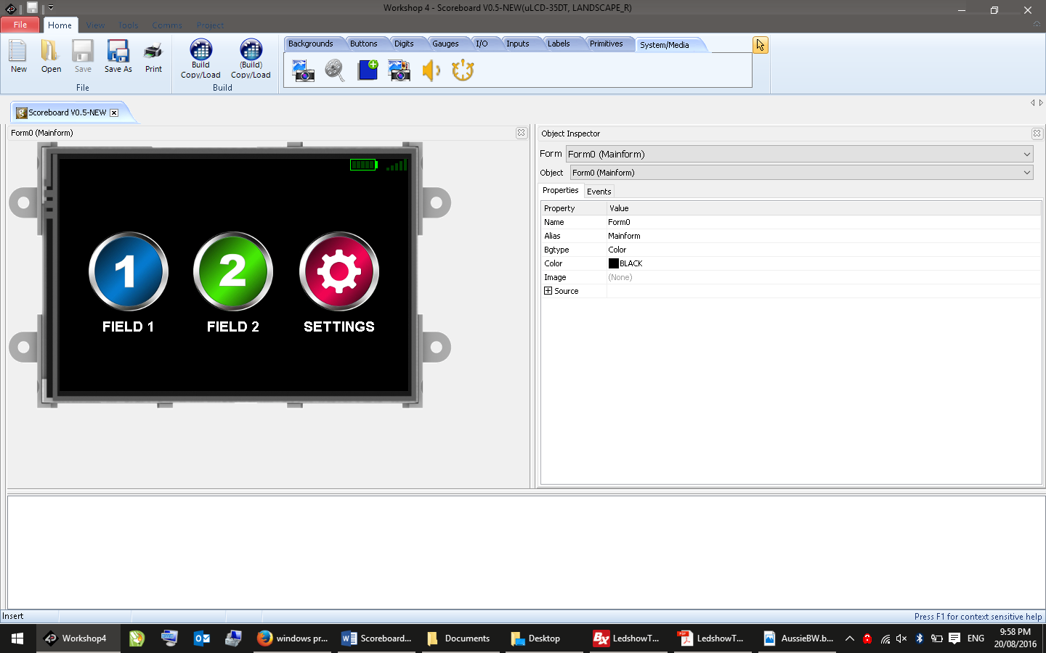

### Field Screens

Each field screen has large buttons to select each score, or the timer.

The top margin shows:

* Battery state of the hand held controller (n.b. it runs on 3 x AA batteries)
* Signal strength between the controller and the scoreboard.

The rubbish bin icon is to reset the scores back to zero.

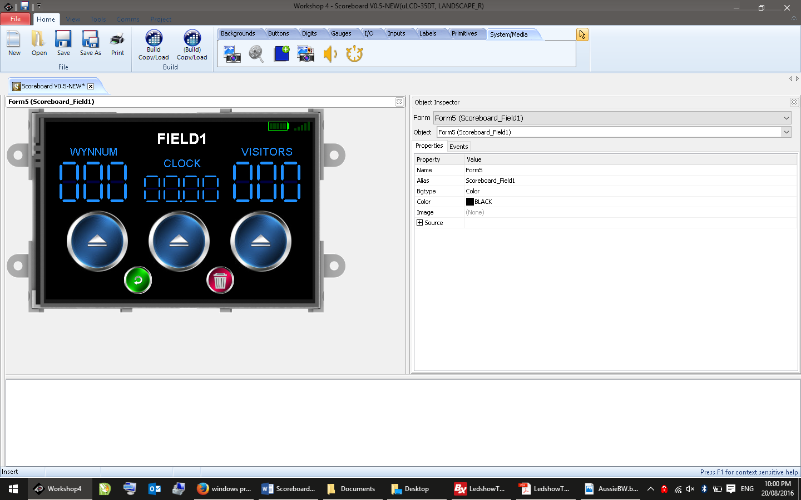

### Set the Score

Use the +/- buttons to set the desired score, then press the green arrow to send it to the scoreboard.

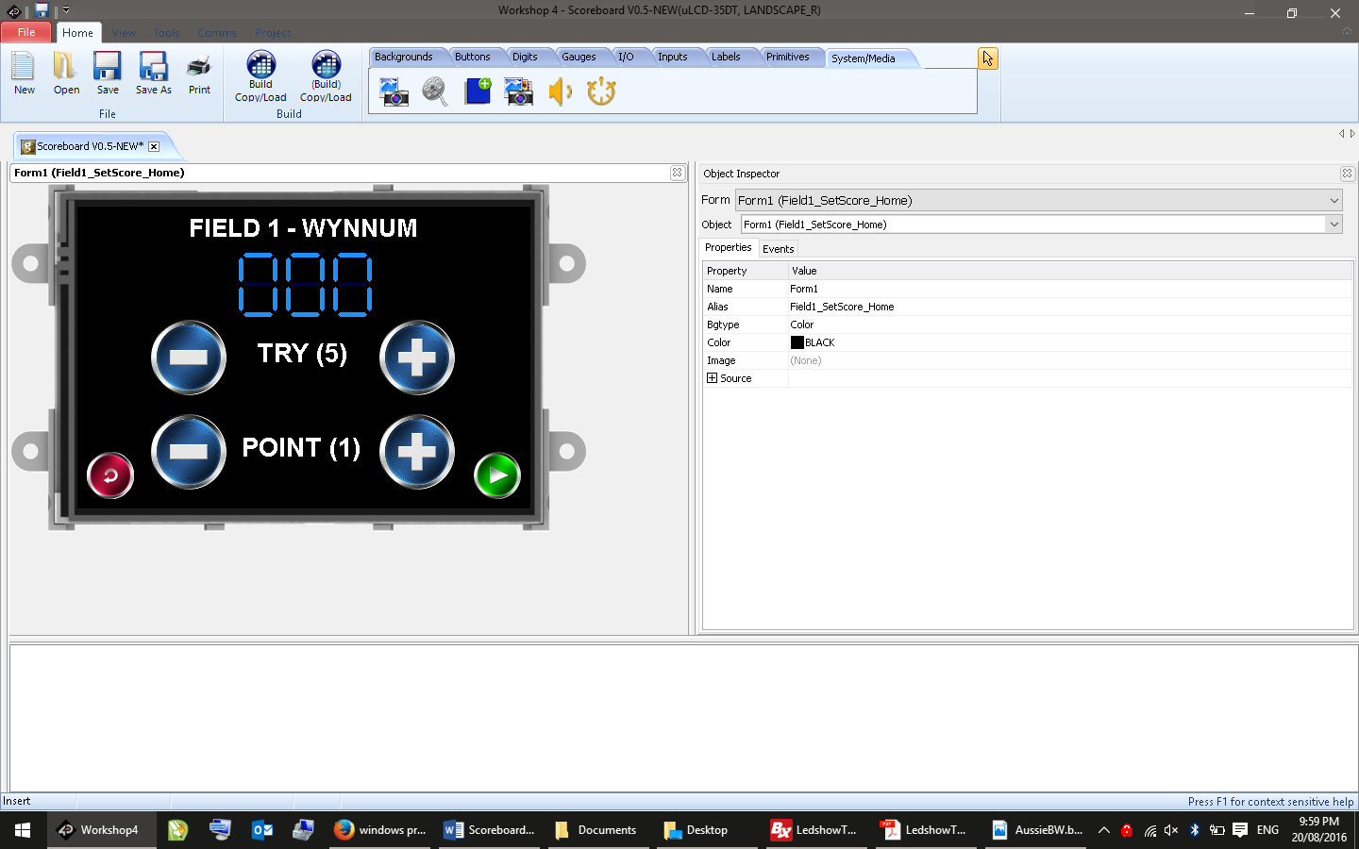

### Timer

Use the Start/Stop/Pause buttons to control the match timer.

At this stage the main scoreboard does not have a dedicated timer display – the timer(s) will only be shown in ‘dual screen’ mode.

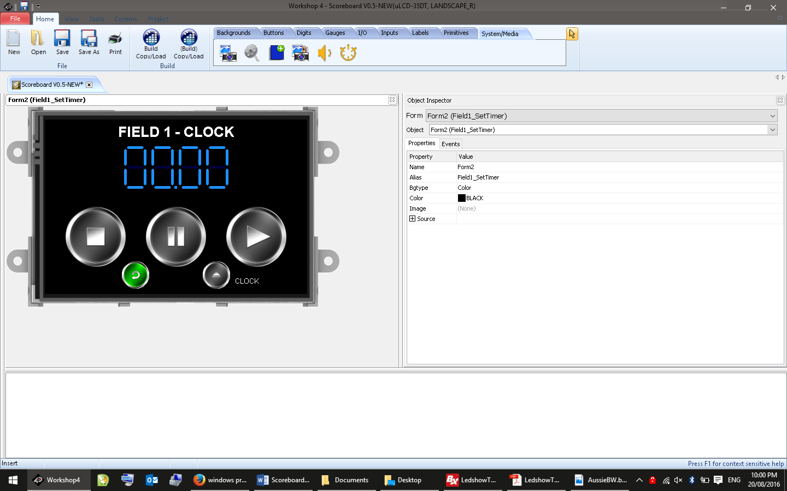

### Settings

Settings are:

* **Dual Fields** – show scores and timer for Field 1 on the left panel and Field 2 on the right
* **Swap Field** – swaps the teams and/or fields left to right and vice versa
* **Brightness** – can be used to dim the display for night conditions (default is full brightness)

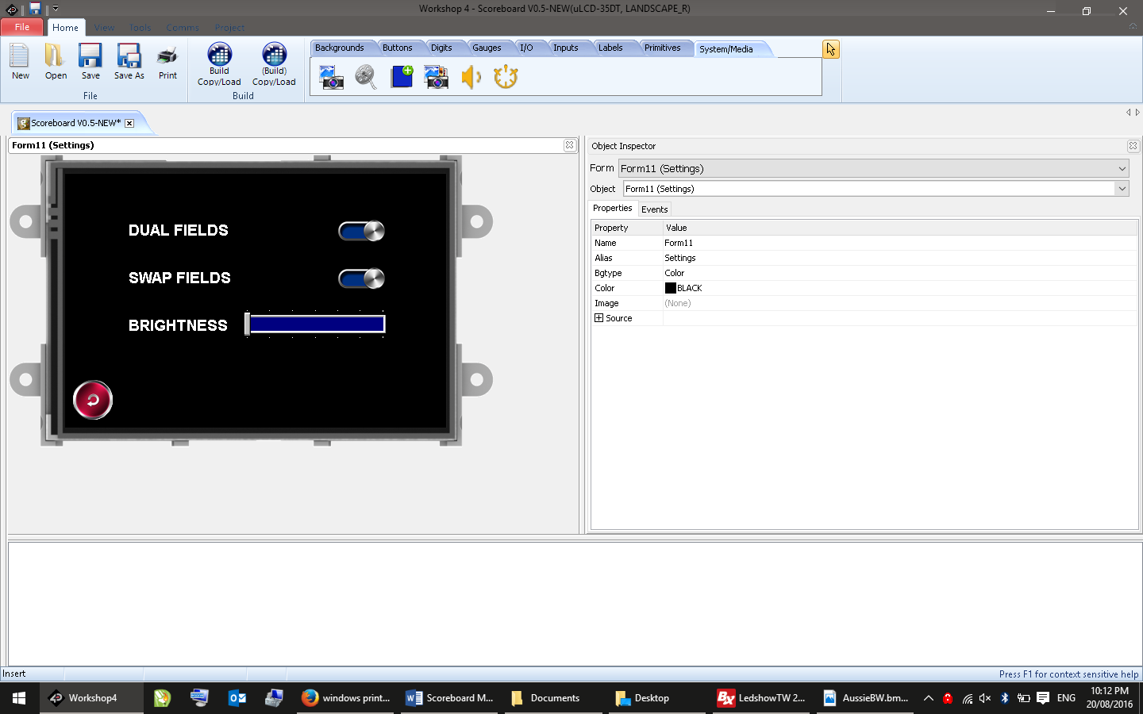

## WIFI HOTSPOT CONTROLLER (CURRENT)

### Overview

The WIFI Hotspot controller provides two separate modes of operation:

* dedicated buttons to manually increment or decrement the score
* an integrated WIFI hotspot allowing control of all scoreboard features.

### Power

The unit is powered by a rechargeable 1000Mah Lithium Polymer battery that should last for at least two or more full games of continuous use. If the battery runs low during a game, it can be plugged in and charged while still controlling the scoreboard.

To recharge the battery connect a standard USB Type B plug to the external socket – allow around 3 to 4 hours to fully charge. The battery has built in protection for over-voltage and minimum state-of-charge.

**WARNING – It IS NOT RECOMMENDED TO LEAVE THE UNIT CONTINUOUSLY CHARGING – DISCONNECT THE CHARGER AFTER THE CONTROLLER IS FULLY CHARGED.**

### Indicators

The hotspot controller has an LED on the front panel to indicate its status:

|  |  |  |
| --- | --- | --- |
| **Display** | | **Meaning** |
|  | Long flash every 2 secs | Low battery – charge immediately (less than 20% remaining) |
|  | Short flash per second | Error – no signal or out of range – move closer |
|  | Short flash per second | Normal – sending or receiving score data |
|  | Short flash occasionally | Normal – sending or receiving WiFi data |

NOTE: Different patterns may ‘mix’ together - for example – if the hotspot controller is connected however about to run out of battery, expect to see the LED flashing red and also blinking green once per second)

### Connecting to WiFi

After powering on the controller, it will automatically establish communications with the scoreboard. To connect to WiFi:

* Open WiFi settings on your device and select the SSID called “Scoreboard”
* Enter the password (at the time of writing the password is “MightyBugs”). The password is case-sensitive.
* After your device has successfully connected to WiFi, open a web browser and navigate to <http://scoreboard> . The web-page controls are similar to the touchscreen controller (see above).

PLACEHOLDER FOR SCREENSHOT

### Controller Placard

The controller has a placard inside the front cover with instructions as follows:

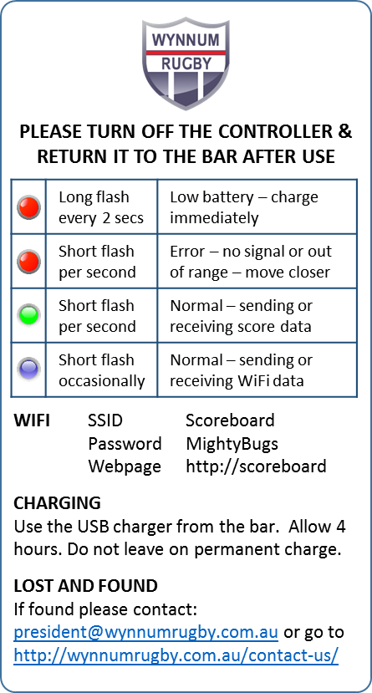

# SPONSORS DISPLAY OPERATION

## OVERVIEW

The sponsor display is area of 7 x 3 panels (224 x 48 blue LED’s) controlled by a commercially available [Onbon BX-5M1 (Ethernet+USB) Controller](http://www.onbonbx.com/en/cp/html/?58.html).

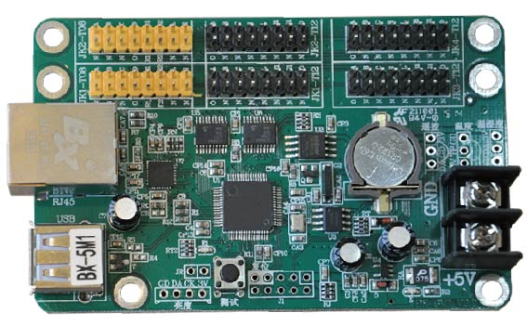

The display is preset using a laptop and normally runs on an automatic loop showing sponsors names (i.e. it is not operated by the handheld controller).

## SOFTWARE

The software to program the board is called LEDShowTW 2016, from Shanghai Onbon.

The software is somewhat quirky, however is free to download and serves the purpose.

### Download

To download from Github:

* Go to <https://www.dropbox.com/sh/sghb6pdirujstwg/AACKP-Y4QCKdH5MuSKMl-b8Ga?dl=0>
* Navigate to the “*Sponsors*” folder and download everything – you’ll need all the files in the following steps.

Alternatively download the LEDShowTW 2016 software from the manufacturer’s site:

* Go to <http://www.onbonbx.com/en/down/class/?7.html> .

### Installation

Unzip the software in the “*Sponsors->LedShow Software*” folder then run the installer and follow the prompts.

### User Manual

There is a user manual for LEDShowTW2012 and LEDShow 2011 in the “*Sponsors->LedShow Software*” folder.

A useful tutorial is on YouTube here -> <https://www.youtube.com/watch?v=Lq9ibgln0VM>

## SETUP

### SCREEN CONFIGURATION

After installation, run the software and select File->Import Configuration Parameters

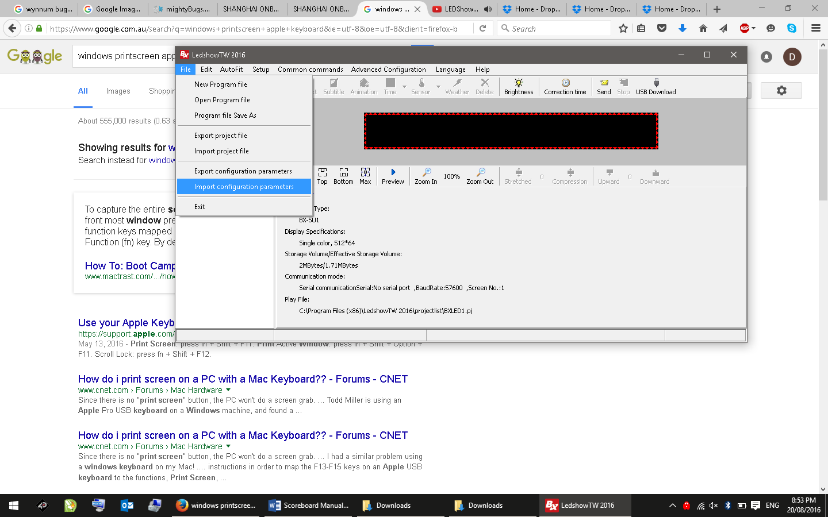

Select OK at the dialog and navigate to the *Sponsors->Screen Config-> LedTW_Config* folder

If import is successful, click on 1-Screen and you should see:

* Controller Type: BX-5M1
* Display Specifications: Single Colour 224 x 48

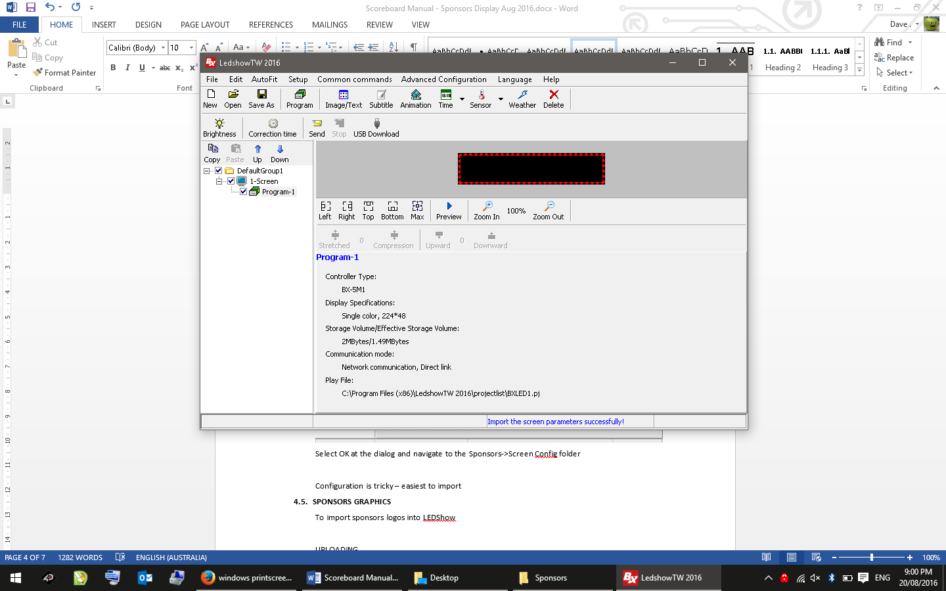

### ADVANCED SETUP

If import above was successful then the screen is ready to use – you shouldn’t need to do anything else.

For reference:

* the password for advanced setup is 888
* the settings for the scoreboard are as follows

It is very important these settings are not altered.

### Screen Parameters

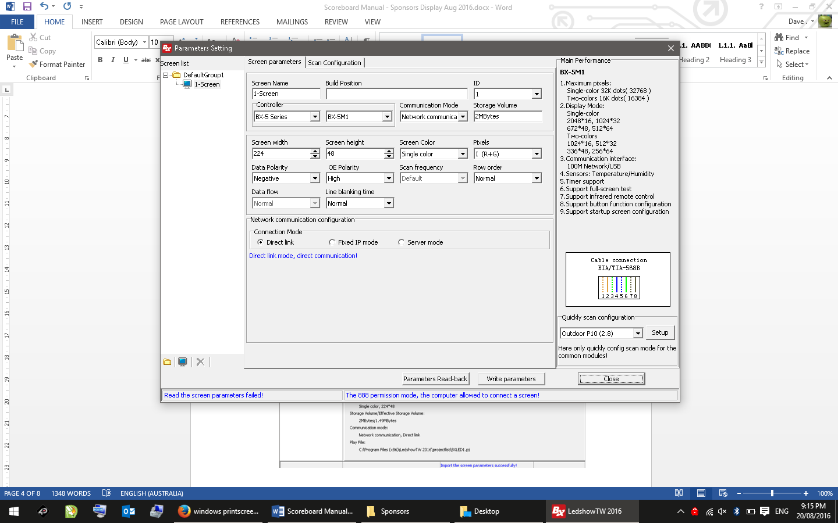

### Scan Configuration

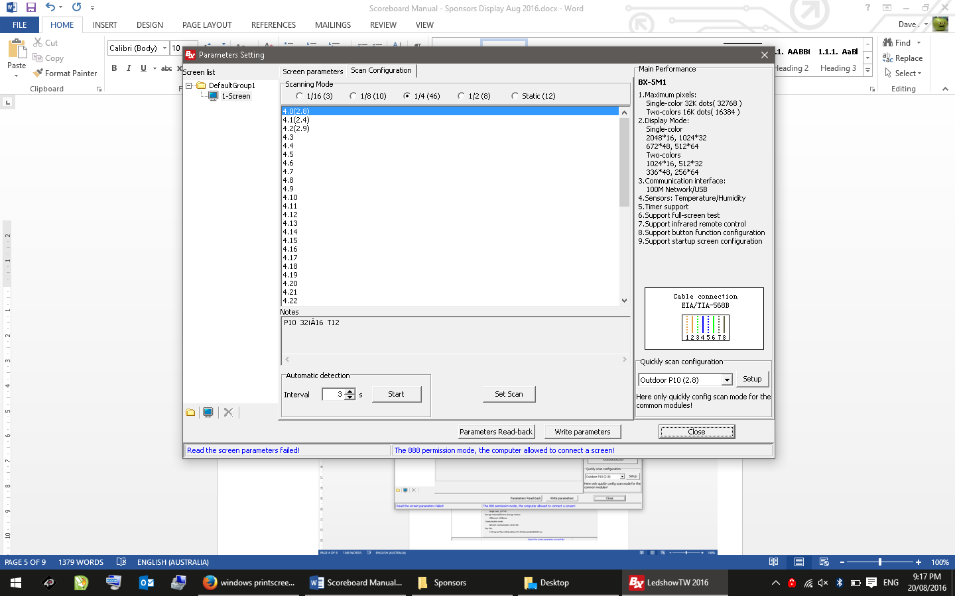

## PROJECT FILE

Next import the project file:

* select *File->Import Project File*
* select OK at the dialog and navigate to the *Sponsors->Sponsors 2016* folder.
* select a project file to import (the latest is in the folder marked (current))

If import is successful, you should see all the logos loaded:

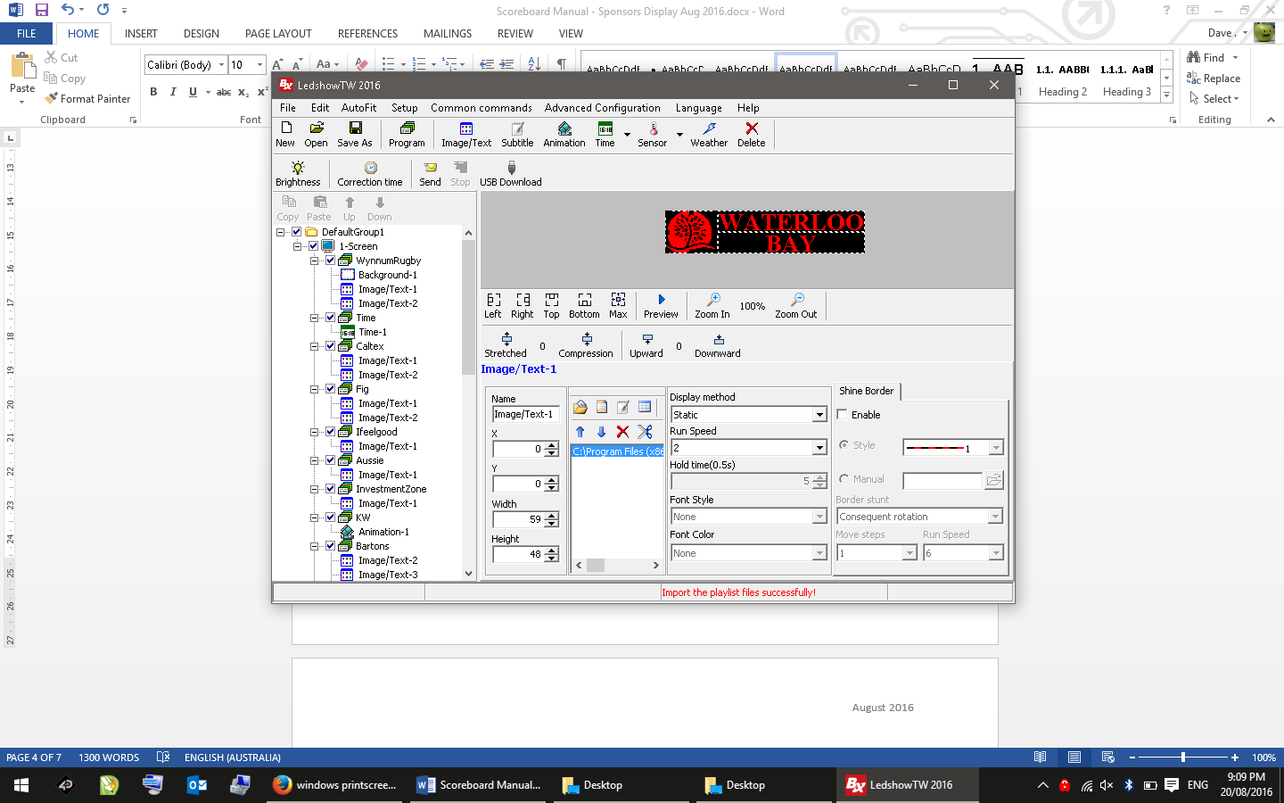

## UPLOADING

To upload:

* connect your PC to the scoreboard BX-5M1 controller using an Ethernet cable (RJ-45)
* press the ‘Send’ icon



Alternatively you can upload using an USB (see instructions in the LedShow pdf manual).

Uploading takes only a few seconds – when it is complete the controller will reboot and immediately show the uploaded program.

## SPONSORS GRAPHICS

If you haven’t already watched this tutorial, now is a good time -> <https://www.youtube.com/watch?v=Lq9ibgln0VM>

To prepare sponsors logos:

* images must be formatted as a bitmap up to 224 x 48 pixels with 1 bit color depth.
* complex logos may need to be hand-drawn using a graphics editor (GIMP, Photoshop etc)

Logos for 2016 are in the *Sponsors -> Sponsors2016 -> LedShow Project [date] -> Documents* folder.

Examples are:

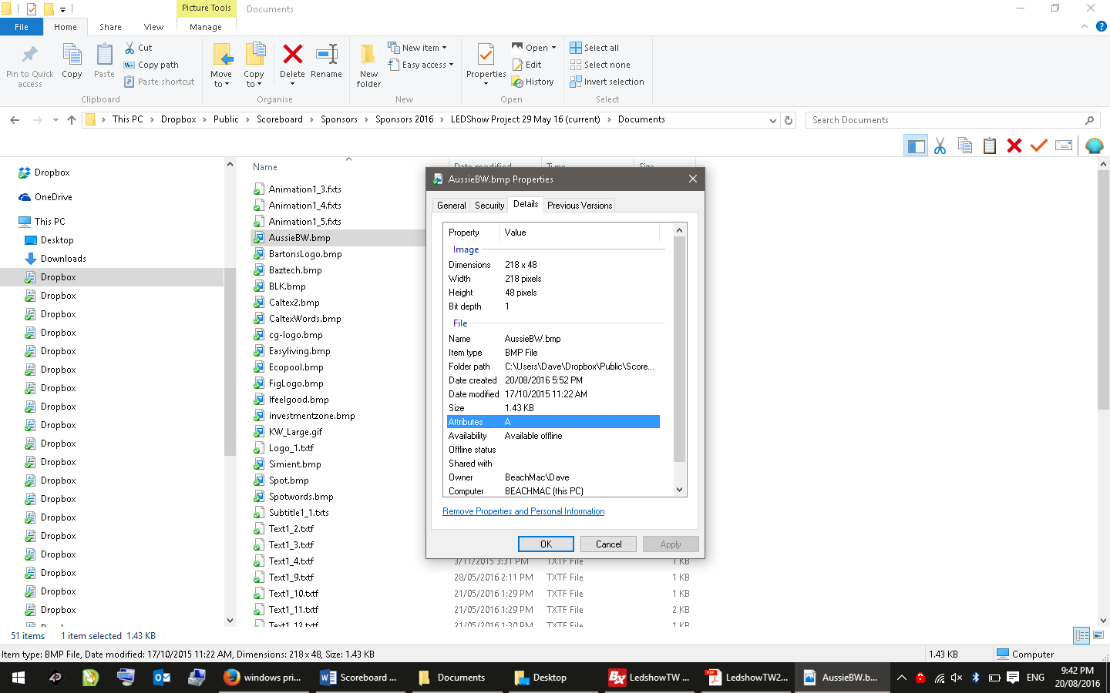 

  

Power on

Connect Ethernet cable between the controller and your PC

Press “Send”

In the status bar “Send Screen Data Successfully”

To correct the time:

If the tome is not holding

# BLOCK DIAGRAMS

## SCORE DISPLAY LOGICAL LAYOUT

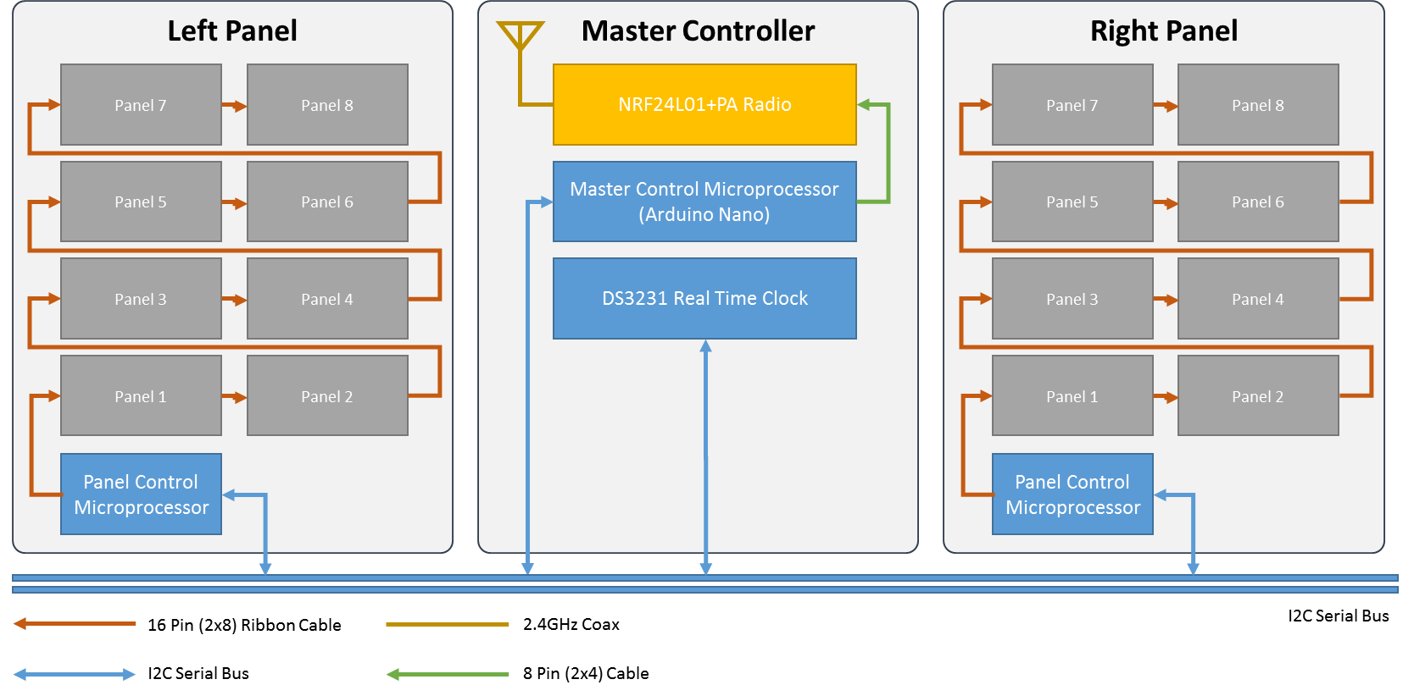

## SCORE DISPLAY POWER LAYOUT

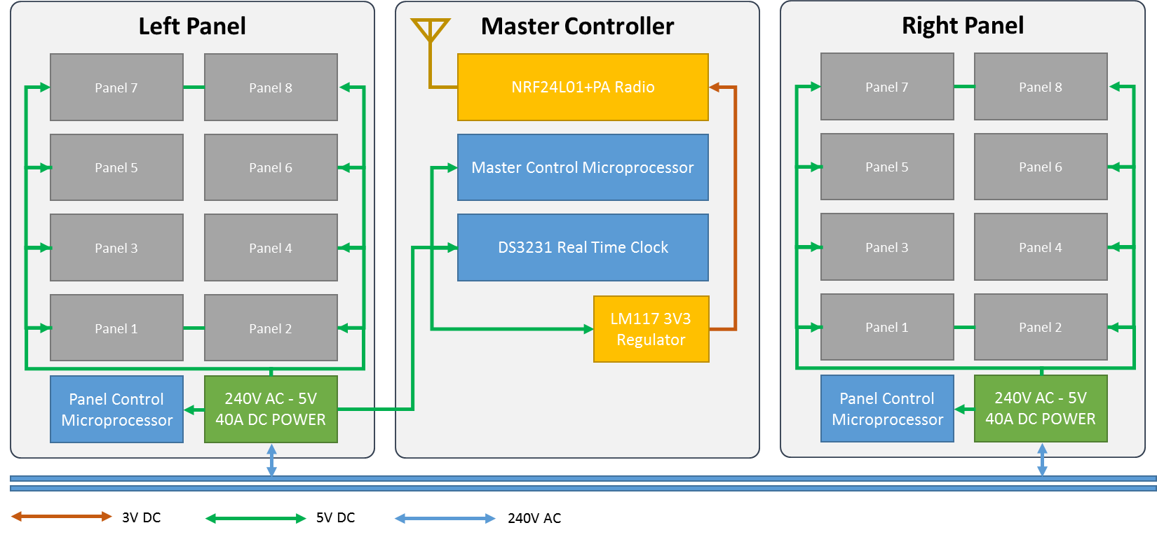

## SPONSORS DISPLAY LOGICAL AND POWER LAYOUT

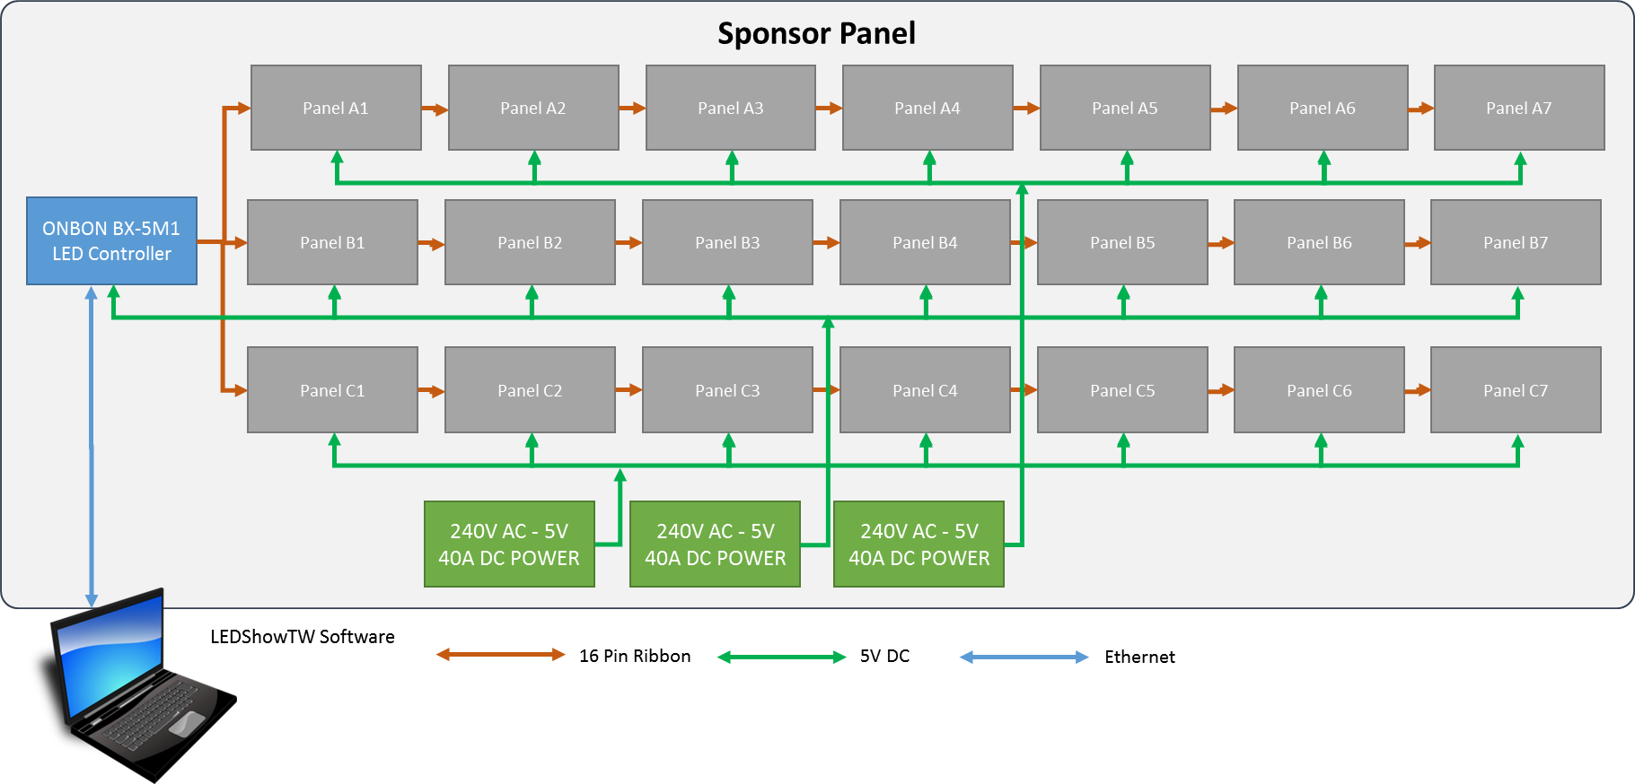

## MASTER & PANEL MICROPROCESSOR PCB

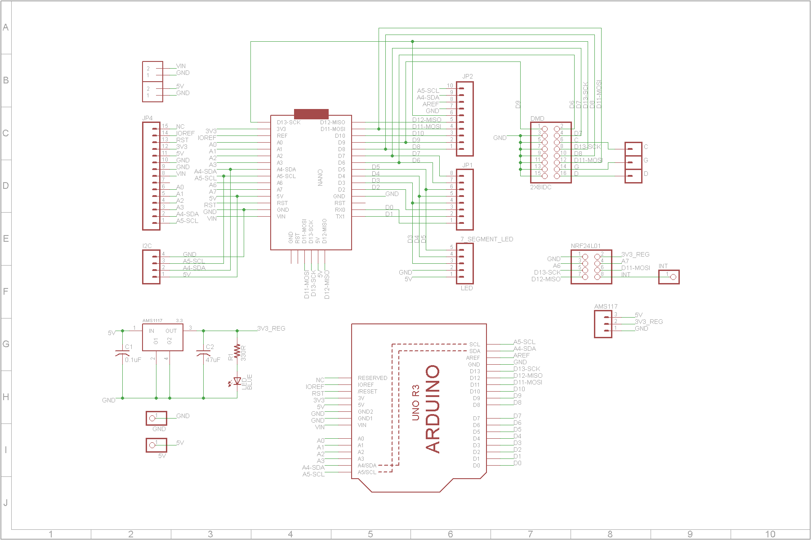

## WIFI CONTROLLER PCB

[PLACEHOLDER]

# HARDWARE AND PARTS

* The scoreboard is mostly built from widely available hardware (eBay, AliExpress etc) with custom printed circuit boards for integration/interfacing of the microcontrollers.
* The tables below list major components – other items used in construction are easily replaceable/repairable.

## SCORE DISPLAY

|  |  |  |  |
| --- | --- | --- | --- |
| **Key Components** | **Quantity** | **Description and Specification** | **Source** |
| LED Panels – White | 2 per display | 32x16 single color LED DMD panel  10mm pitch (P10)  Waterproof / Outdoor  10 pin SPI Interface / 5V Power  http://i.ebayimg.com/images/g/nPIAAOSwwbdWGWay/s-l1600.jpg | [Aliexpress](http://www.aliexpress.com/wholesale?catId=0&initiative_id=SB_20160820043909&SearchText=p10+outdoor+led+module) |
| LED Panels – Blue | 6 per display |
| Microprocessor Module | 1 per panel plus 1 for controller (3 total) | Arduino Nano (ATMEL ATMega328P) V3.2  (do not use V3.1 or below as pinouts are different)  http://store.iteadstudio.com/images/icon/arduinonano.jpg | [Ebay](http://www.ebay.com.au/sch/i.html?_from=R40&_trksid=p2050601.m570.l1313.TR4.TRC2.A0.H0.Xarduino+nano.TRS0&_nkw=arduino+nano&_sacat=0) |
| Circuit Board | 1 per panel plus 1 for controller (3 total) | Custom circuit board (see downloads below for schematic) | Custom PCB – see Eagle files |
| Voltage Regulator | 1 for main controller | AMS1117 3.3V 3V3 800mA Voltage Regulator  http://i.ebayimg.com/images/g/sOQAAOSwgQ9Vu8wq/s-l300.jpg | [Ebay](http://www.ebay.com.au/sch/i.html?_odkw=ams1117&_osacat=0&_from=R40&_trksid=p2045573.m570.l1313.TR0.TRC0.H0.Xams1117+3.3.TRS0&_nkw=ams1117+3.3&_sacat=0) |
| Radio Transmitter | 1 for main scoreboard / 1 for each handheld controller (3 total) | NRF24L01+ with high power amp  https://www.mysensors.org/radio/antenna.png | [Ebay](http://www.ebay.com.au/sch/i.html?_odkw=NRF24L01%2B&_osacat=0&_from=R40&_trksid=p2045573.m570.l1313.TR0.TRC0.H0.XNRF24L01%2B+PA.TRS0&_nkw=NRF24L01%2B+PA&_sacat=0) |
| Real Time Clock | 1 for main scoreboard | DS3231 AT24C32 IIC Precision RTC Real Time Clock Memory Module | [Ebay](http://www.ebay.com.au/sch/i.html?_odkw=DS3221&_osacat=0&_from=R40&_trksid=p2045573.m570.l1313.TR0.TRC0.H0.XDS3231.TRS0&_nkw=DS3231&_sacat=0) |
| Power Supply | 1 per display panel (2 total) | 110V-240V AC-DC 5V 40A LED Light Switching Power Supply Universal Transformer  Each power supply feeds up to 8 LED panels @ 4A each = up to 36A total load  Must be fanless (fans will fail)  http://i.ebayimg.com/images/g/HGMAAOSwZ1lWg2kh/s-l500.jpg | [Ebay](http://www.ebay.com.au/sch/i.html?_odkw=DS3231&_osacat=0&_from=R40&_trksid=p2045573.m570.l1313.TR12.TRC2.A0.H0.X5V+40A.TRS0&_nkw=5V+40A&_sacat=0) |
| Power wiring | As required | Must be able to carry 4A per panel connected (each panel draws approx. 4Amps peak when all LED’s are on) | Ebay |
| Data wiring | As required | 10 core ribbon cable | Jaycar |

## SPONSORS DISPLAY

|  |  |  |  |
| --- | --- | --- | --- |
| **Key Components** | **Quantity** | **Description and Specification** | **Source** |
| LED Panels – Blue | 21 per display | 32x16 single color LED DMD panel  10mm pitch (P10)  Semi-waterproof / Outdoor  10 pin SPI Interface  http://i.ebayimg.com/images/g/nPIAAOSwwbdWGWay/s-l1600.jpg | [Aliexpress](http://www.aliexpress.com/wholesale?catId=0&initiative_id=SB_20160820043909&SearchText=p10+outdoor+led+module) |
| Controller Module | 1 unit runs both displays | Onbon BX-5M1  May be substituted for any commercially available controller capable of running 3 x rows of 224 x 16 pixels  http://www.onbonbx.com/en/cp/html/images/1466478610.jpg | Aliexpress |
| Power Supply | 3 total | 110V-240V AC-DC 5V 40A LED Light Switching Power Supply Universal Transformer  Each power supply feeds up to 8 LED panels @ 4A each = up to 36A total load  Must be fanless (fans will fail)  http://i.ebayimg.com/images/g/HGMAAOSwZ1lWg2kh/s-l500.jpg | [Ebay](http://www.ebay.com.au/sch/i.html?_odkw=DS3231&_osacat=0&_from=R40&_trksid=p2045573.m570.l1313.TR12.TRC2.A0.H0.X5V+40A.TRS0&_nkw=5V+40A&_sacat=0) |
| Power wiring | As required | Must be able to carry 4A per panel connected (each panel draws approx. 4Amps peak when all LED’s are on) | Ebay |
| Data wiring | As required | 10 core ribbon cable | Jaycar |

## TOUCHSCREEN CONTROLLER

|  |  |  |  |
| --- | --- | --- | --- |
| **Key Components** | **Quantity** | **Description and Specification** | **Source** |
| Microprocessor Module | 1 ea | Arduino Nano (ATMEL ATMega328P) V3.2  (do not use V3.1 or below as pinouts are different)  http://store.iteadstudio.com/images/icon/arduinonano.jpg | [Ebay](http://www.ebay.com.au/sch/i.html?_from=R40&_trksid=p2050601.m570.l1313.TR4.TRC2.A0.H0.Xarduino+nano.TRS0&_nkw=arduino+nano&_sacat=0) |
| Circuit Board | 1 ea | Custom circuit board (see downloads below for schematic) | Custom PCB – see Eagle files |
| Voltage Regulator | 1 ea | AMS1117 3.3V 3V3 800mA Voltage Regulator  http://i.ebayimg.com/images/g/sOQAAOSwgQ9Vu8wq/s-l300.jpg | [Ebay](http://www.ebay.com.au/sch/i.html?_odkw=ams1117&_osacat=0&_from=R40&_trksid=p2045573.m570.l1313.TR0.TRC0.H0.Xams1117+3.3.TRS0&_nkw=ams1117+3.3&_sacat=0) |
| Radio Transmitter | 1 ea | NRF24L01+ with high power amp, SMA Antenna  https://www.mysensors.org/radio/antenna.png | [Ebay](http://www.ebay.com.au/sch/i.html?_odkw=NRF24L01%2B&_osacat=0&_from=R40&_trksid=p2045573.m570.l1313.TR0.TRC0.H0.XNRF24L01%2B+PA.TRS0&_nkw=NRF24L01%2B+PA&_sacat=0) |
| Touchscreen | 1 ea | uLCD-35DT 3.5" 480x320 Intelligent Display Module  http://www.4dsystems.com.au/images/product_slides/uLCD-35DT_s_01.jpg | [4D Systems](http://www.4dsystems.com.au/product/uLCD_35DT/)  [Mouser](http://au.mouser.com/ProductDetail/4D-Systems/uLCD-35DT/?qs=BP4PhI%252bVHUuSJUapCWI92w%3d%3d) |
| Other components | 1 ea | Battery regulator  3 x AA battery holder  Power switch  3D printed assembly  Laser cut front panel |  |

## WIFI CONTROLLER

|  |  |  |  |
| --- | --- | --- | --- |
| **Key Components** | **Quantity** | **Description and Specification** | **Source** |
| Microprocessor Module | 1 per controller | Adafruit Feather Huzzah With Esp8266 Wifi  <https://www.adafruit.com/product/2821>  http://media.rs-online.com/t_large/R1245505-02.jpg | [Little Bird Electronics](https://littlebirdelectronics.com.au/) |
| Circuit Board | 1 for controller | Custom circuit board (see downloads below for schematic) | Custom PCB – see Eagle files |
| Radio Transmitter | 1 ea | NRF24L01+ with high power amp, SMA Antenna  https://www.mysensors.org/radio/antenna.png | [Ebay](http://www.ebay.com.au/sch/i.html?_odkw=NRF24L01%2B&_osacat=0&_from=R40&_trksid=p2045573.m570.l1313.TR0.TRC0.H0.XNRF24L01%2B+PA.TRS0&_nkw=NRF24L01%2B+PA&_sacat=0) |
| Lipo Battery Monitor | 1 ea | SparkFun LiPo Fuel Gauge (MAX17043G+U)  SparkFun LiPo Fuel Gauge | [Little Bird Electronics](https://littlebirdelectronics.com.au/) |
| I2C IO Port Expander | 1 ea | Pcf8574 Pcf8574t I2c 8 Bit Io Gpio Expander Module  (RED VERSION AS SHOWN BELOW / DO NOT BUY THE BLUE VERSION)  Image result for pcf io expander | [Ebay](http://www.ebay.com.au/itm/PCF8574T-I-O-I2C-Port-Interface-Support-Arduino-Cascading-Extended-Module-/191736125266?hash=item2ca45d1752:g:PNIAAOSwGotWlv-Q) |
| LiPo Battery | 1 ea | 3.7V Polymer Lithium Ion Battery - 1000mAh with JSF connector for HUZZAH Feather  Battery MUST include low voltage protection  3.7V Polymer Lithium Ion Battery - 1000mAh FIT0120 DFRobot Australia - Express Post Australia Wide (Feature image) | [Little Bird Electronics](https://littlebirdelectronics.com.au/) |
| Other components | 1 ea | SMA antenna pigtail  SMA faceplate connector  4.7K Resistors x 2  330 Ohm Resistors x 3  Momentary pushbutton switches x 4  Rocker switch x 1  Hookup wire  Laser cut front panel  RGB LED  Panel mount USB Type B socket to micro-USB plug | Jaycar, various |

# DESIGN FILES

Design files are available on GitHub here -> <https://github.com/Dave1001/Scoreboard>

To view detailed designs, download the following software packages:

* PCB Layout - Eagle PCB version 7.0 or higher - <https://www.autodesk.com/products/eagle/overview>
* 3D Design – Solidworks 2017 or higher - <http://www.solidworks.com/>

# PROGRAMMING

## SOFTWARE DEVELOPMENT ENVIRONMENT

All software was developed on a Windows PC using the following tools (current as of July 2017).

### Microsoft Visual Studio Community 2017 (C/C++)

Visual Studio is licensed free from Microsoft available from <https://www.visualstudio.com/en-us/downloads/download-visual-studio-vs.aspx>

### Visual Micro

Visual Micro is a toolset that integrates into Visual studio, available from <http://www.visualmicro.com/> . You also need the Arduino IDE for Visual Micro to function correctly.

### Arduino IDE Version 1.6.9

Arduino is a widely used development environment available from <https://www.arduino.cc/> . The code should (might) compile using Arduino IDE alone as it uses the same underlying GCC compiler as Visual Micro. In practice however Visual Studio/Visual Micro are far easier and provides many useful debugging tools (compile and upload solely using the Arduino IDE has not recently been tested).

### Touchscreen

The touchscreen is a stand-alone display processor that’s reasonably powerful in its own right. The software is developed using the WorkShop 4 IDE from 4D Systems available at <http://www.4dsystems.com.au/product/4D_Workshop_4_IDE/>

## SOFTWARE LIBRARIES

Libraries are all downloadable from <coming soon>. Instructions to install the libraries in the correct folder for Arduino are here <coming soon>

## RESOURCE FILES

## SOURCE CODE

Source code is in two parts

Scoreboard Library – class definitions and library files that need to be copied to the same location as other Arduino Libraries (see above)

Visual Studio Solution

Both are available from here

## COMPILING

## UPLOADING